1. Join EMPLOYEES with DEPARTMENTS to show department names.

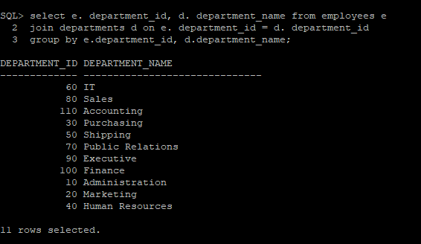

1. Display employees with their manager’s full name.

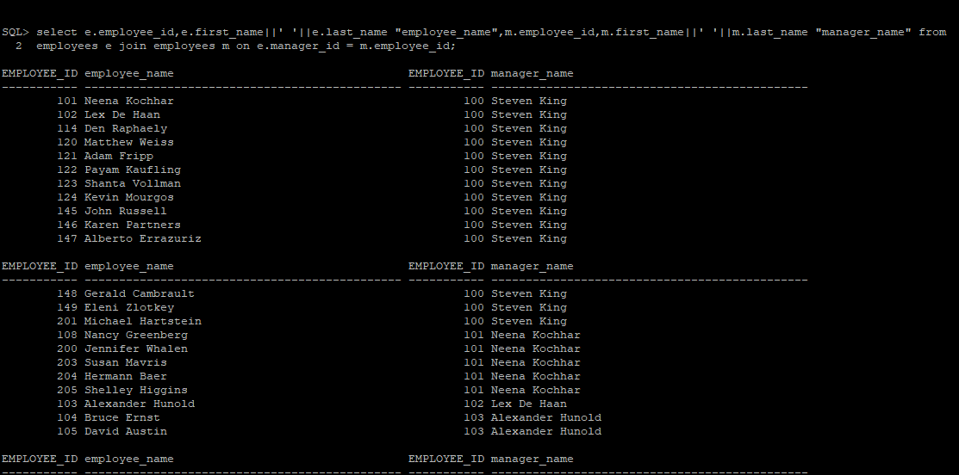

1. Show employee names along with job titles from JOBS table.

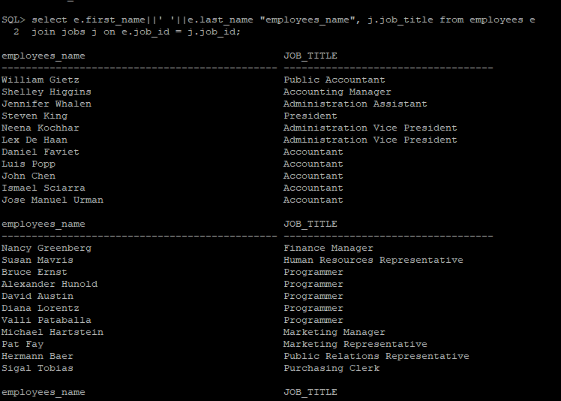

1. List employees along with department name and location.

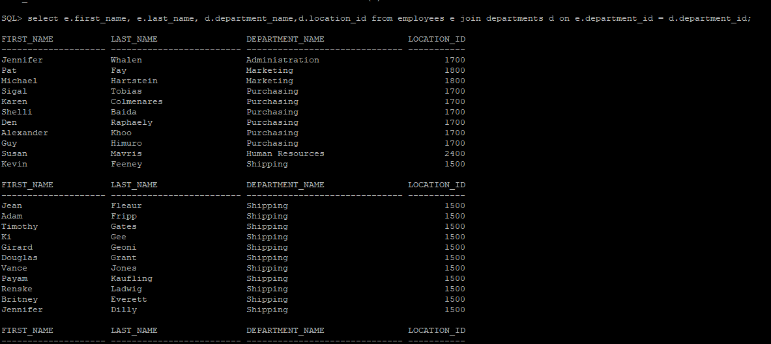

1. Show employees and the names of their managers (self-join).

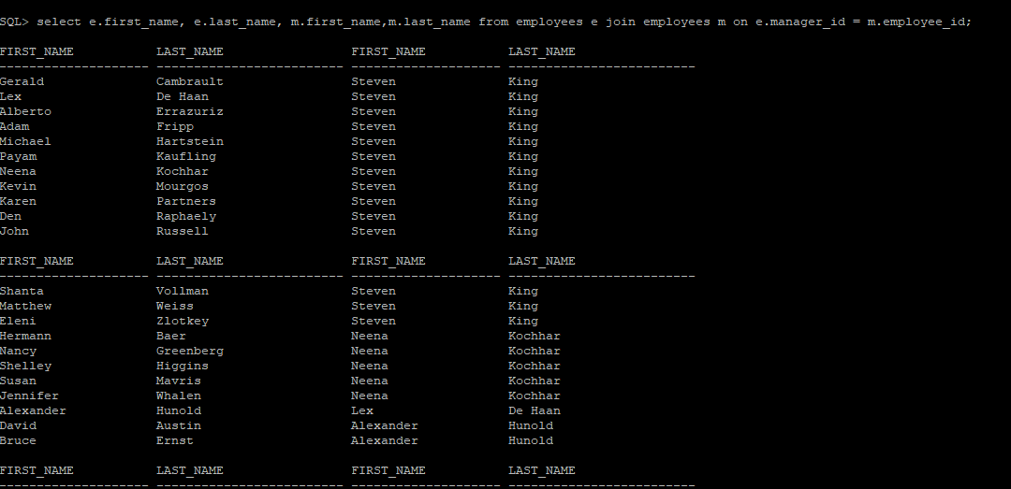

Here in the above query alias should be given so as to make the query more readable i.g select e.first_name, “employee’s first name” e.last_name as “employee’s last_name” and vise versa to manager as well to identify which on is employee and which one is manager.

1. Show employees in departments located in 'New York'.

7 List job title, employee name, and salary.

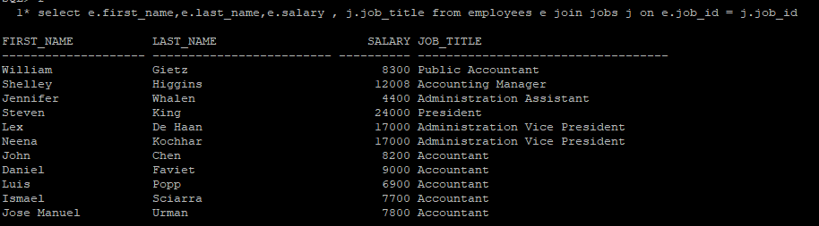

8 Display departments with no employees.



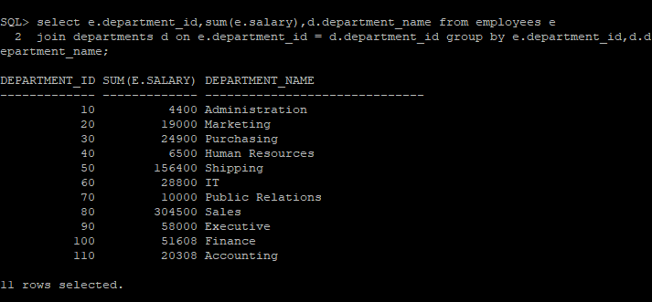

9 List all employees and their managers, including employees without managers

10 Find the total salary by department and job title. 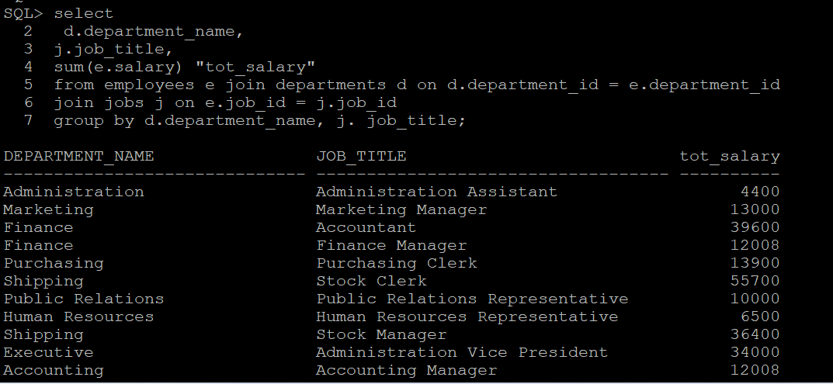

1. Get employees who work in the same department as 'Steven King

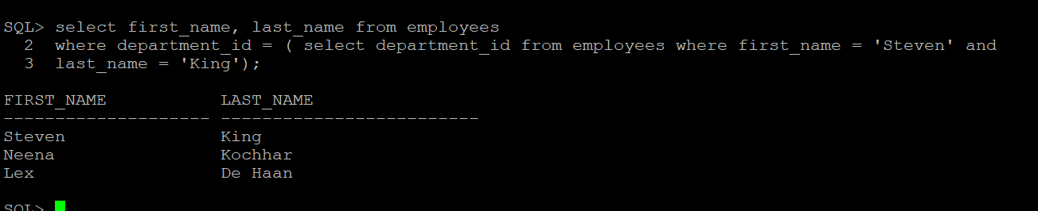

12 Find employees who have the same job title as their manager.



Show employees whose salary is more than their manager's.

